Master of Science in Data Science (DS)

"Mental Health at Workplace"



TEAM MEMBERS:

Likhith Sai Chaitanya 00764343

Phobi Shrestha 00769089

Sai Rohith Sunkara 00770130

Sivaleela Yaramala

Udith Kumar Tene 00763052

Contents

**Executive Summary** 3

**Review of available research** 3

**Challenge** 4

**Solution** 4

User Stories 5

Graphical View of ETL Tools 6

Data 6

Exploratory Data Analysis 7

Tools that we are going to use to solve this problem 8

Models that we are going to use to solve this problem 8

**Conclusion** 9

References9

# Executive Summary

With the development of new data sources and analytical methods, data science has become more and more prevalent in the healthcare industry. In terms of mental health, there is a huge unmet demand in the world. Data science can contribute to our understanding of mental health issues. We may use data science to more fully comprehend and successfully apply treatments for mental health issues.

In this report, we will try to understand the factors that are contributing to the mental health of a person. The dataset used in this project is from Kaggle which is extracted from a 2014 survey that measures attitudes toward mental health and the frequency of mental health disorders in the workplace. From this project, we get to understand mental health in the workplace in a systematic manner.

# Review of available research

Since the beginning of the covid pandemic, most work institutions around the world have gone to the online model which develops more work pressure and mental pressure due to work and family management.

Mental healthcare itself is a site of stigmatization as many healthcare providers hold stigmatizing notions within mental healthcare settings and have been identified as a major barrier to access treatment and recovery, as well as poorer quality physical care for persons with mental illness. Leaders should encourage fellows to share their psychological distress in safe spaces and validate their concerns. The persistent stigma around mental illness in the medical community, both interpersonal and self-stigma, often deters clinicians from seeking help.

The lack of information about the functioning and effectiveness of the mental health services focused on youth is an obstacle to assessing and, therefore, improving the services.In a healthy society, Manufacturing companies are responsible for more than just producing profitable quantities of goods and services, and their managers are aware that efficient management leads to increased production. However, this crucial goal cannot be achieved without a commitment to and belief in the mental health of the workforce. So, one of the responsibilities of every capable, savvy, and resourceful manager is to look out for the mental health of the team members.

In terms of all mental health problems, bipolar disorder is one of the major forms of depression. Regarding mental health, a survey was conducted among adults and got observations. These observations were used by the machine learning algorithm like systematic fulfillment and argued to enhance the validity of ML approach. With this advancement in the medical field and using the social network in the field to detect in the field. To make it effective it Is necessary to combine the clinical variables using database management tools such as big data. In this MongoDB is one of the tools to handle big data and extract the information and give accurate results in treating several mental disorder problems with low cost and high efficiency.

# Challenge

How to handle mental health at the workplace

Mental Health affects mental, psychological, and social well-being. It also affects how we think, feel and act. It also helps us in determining how we handle stress by relating it to others. The impact of mental health on an organization can mean a lot of things: an increase in absent days from work, Decrease in productivity. In the US, approximately 70 percent of adults with depression are in the workforce. Employees with depression will miss a lot of days.

# Solution

This problem can be solved using Mental Health First Aid. It helps participants to notice and support individuals who are suffering from mental health. It teaches employees communication and support skills which can help people suffering from mental health.

Research shows that employees who used first aid have increased awareness of mental health among themselves and their co-workers. It allows them to recognize the signs of someone who is struggling with mental health and teaches them the skills to when and where to reach out.

Moreover, they conduct an Employee Assistance Program which focuses on mental and physical health. These measures can help create a healthy and productive work environment that reduces the stigma associated with mental illness.

User Stories

As an employee I want to register into the system so that I can access the system.

As an employee I want to login to the system so that I can view my projects and tasks assigned.

As an employee I want to report any issue regarding mental illness in the portal to the mental health awareness team.

As a member of the mental health awareness team I will look into the portal and try to solve the issue.

As a database administrator I need to check whether the data regarding mental health is properly being updated into the backend or not.

As a data analyst I want to find the percentage of employees suffering from mental health related issues so that necessary precautions can be taken.

As a data scientist I want to create a model so that it can predict if any employee is suffering from mental illness by providing his/her symptoms.

As an app developer I want to create a good and interactive user interface so that every user can access it easily.

As a team leader I want to make sure that every task of the project is going without any issue.

As an employee I want to logout my account so that no one can access it except myself.

Graphical View of ETL Tools :

Data

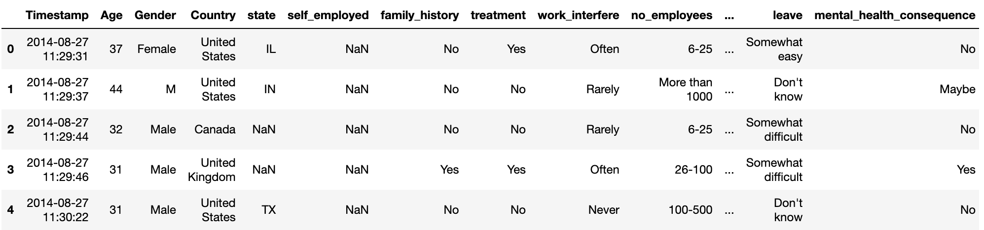

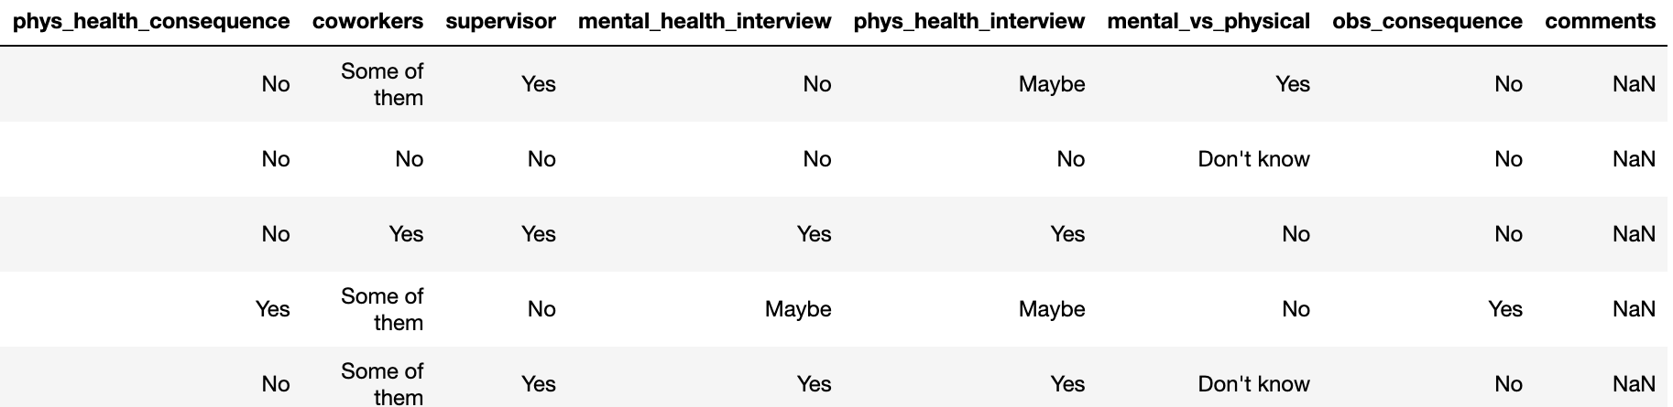

Exploratory Data Analysis

We will drop the comments column because 70% of the column have null values. Moreover we will also drop the Timestamp column which tells when the questionnaire was taken which is irrelevant to us. Also we will drop the state and country column as most of the states are from the US and all the countries except US have less participants.

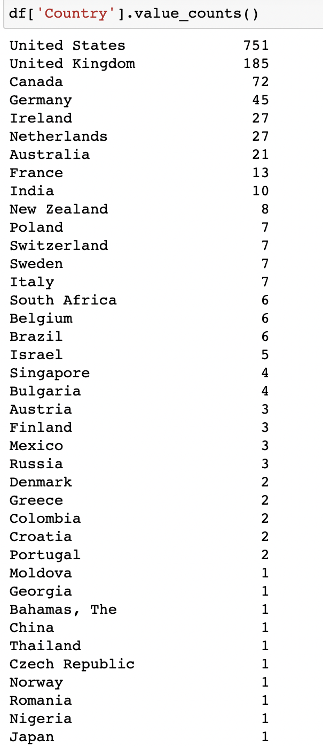

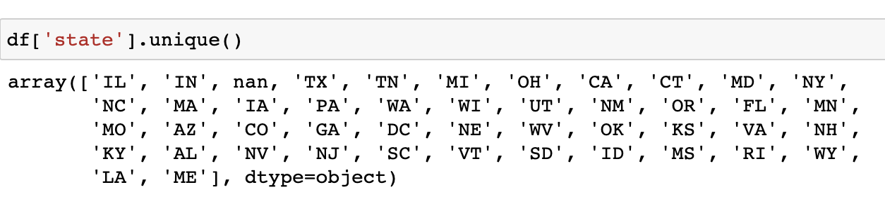

Tools that we are going to use to solve this problem :

JUPYTER : We use jupyter to load our dataset , train and test the data using machine learning algorithms to predict the accuracy.

Numpy, Scikit-Learn, Pandas, Matplotlib,

AWS : We use AWS for hosting the web application into a flask server.



Models that we are going to use to solve this problem :

We are going to use Random Forest Classifier,Gradient Boost and AdaBoost Classifier as they are going to give higher accuracy than other models since they are combinations of different models.

# 

# Conclusion

This project is undertaken by five students of Distributed and Scalable Data Engineering with the supervision of Pro. Dr. Ardiana Sula. This project will be performed in CRISP methodology which has a detailed analysis with the subheadings.

* Business Understanding
* Data Understanding
* Data Preparation
* Modeling
* Evaluation
* Deployment

NOTE: All the remaining project modules will be submitted in the final project in the given deadline.

References

<https://www.researchgate.net/publication/268223440_Mental_health-related_stigma_in_health_care_and_mental_health-care>

<https://www.researchgate.net/publication/264502507_Employee_Health_in_the_Mental_Health_Workplace_Clinical_Administrative_and_Organizational_Perspectives>

https://www.kaggle.com/code/aditimulye/mental-health-at-workplace